The Landlady – Roald Dahl
Billy Weaver had travelled down from London on the slow afternoon train, with a change at Swindon on the way, and by the time he got to Bath it was about nine o’clock in the evening and the moon was coming up out of a clear starry sky over the houses opposite the station entrance. But the air was deadly cold and the wind was like a flat blade of ice on his cheeks.
“Excuse me,” he said, “but is there a fairly cheap hotel not too far away from here?”
“Try The Bell and Dragon,” the porter answered, pointing down the road. “They might take you in. It’s about a quarter of a mile along on the other side.”
Billy thanked him and picked up his suitcase and set out to walk the quarter-mile to The Bell and Dragon. He had never been to Bath before. He didn’t know anyone who lived there. But Mr Greenslade at the Head Office in London had told him it was a splendid city. “Find your own lodgings,” he had said, “and then go along and report to the Branch Manager as soon as you’ve got yourself settled.”
Billy was seventeen years old. He was wearing a new navy-blue overcoat, a new brown trilby hat, and a new brown suit, and he was feeling fine. He walked briskly down the street. He was trying to do everything briskly these days. Briskness, he had decided, was the one common characteristic of all successful businessmen. The big shots up at Head Office were absolutely fantastically brisk all the time. They were amazing.
There were no shops on this wide street that he was walking along, only a line of tall houses on each side, all them identical. They had porches and pillars and four or five steps going up to their front doors, and it was obvious that once upon a time they had been very swanky residences. But now, even in the darkness, he could see that the paint was peeling from the woodwork on their doors and windows, and that the handsome white façades were cracked and blotchy from neglect.
Suddenly, in a downstairs window that was brilliantly illuminated by a street-lamp not six yards away, Billy caught sight of a printed notice propped up against the glass in one of the upper panes. It said BED AND BREAKFAST. There was a vase of yellow chrysanthemums, tall and beautiful, standing just underneath the notice. He stopped walking. He moved a bit closer.
Green curtains (some sort of velvety material) were hanging down on either side of the window. The chrysanthemums looked wonderful beside them. He went right up and peered through the glass into the room, and the first thing he saw was a bright fire burning in the hearth. On the carpet in front of the fire, a pretty little dachshund was curled up asleep with its nose tucked into its belly.
The room itself, so far as he could see in the half-darkness, was filled with pleasant furniture. There was a baby-grand piano and a big sofa and several plump armchairs; and in one corner he spotted a large parrot in a cage. Animals were usually a good sign in a place like this, Billy told himself; and all in all, it looked to him as though it would be a pretty decent house to stay in. Certainly it would be more comfortable than The Bell and Dragon.
On the other hand, a pub would be more congenial than a boarding-house. There would be beer and darts in the evenings, and lots of people to talk to, and it would probably be a good bit cheaper, too. He had stayed a couple of nights in a pub once before and he had liked it. He had never stayed in any boarding-houses, and, to be perfectly honest, he was a tiny bit frightened of them. The name itself conjured up images of watery cabbage, rapacious landladies, and a powerful smell of kippers in the living-room.
After dithering about like this in the cold for two or three minutes, Billy decided that he would walk on and take a look at The Bell and Dragon before making up his mind. He turned to go. And now a queer thing happened to him. He was in the act of stepping back and turning away from the window when all at once his eye was caught and held in the most peculiar manner by the small notice that was there.
BED AND BREAKFAST, it said. BED AND BREAKFAST, BED AND BREAKFAST, BED AND BREAKFAST. Each word was like a large black eye staring at him through the glass, holding him, compelling him, forcing him to stay where he was and not to walk away from that house, and the next thing he knew, he was actually moving across from the window to the front door of the house, climbing the steps that led up to it, and reaching for the bell.
He pressed the bell. Far away in a back room he heard it ringing, and then at once – it must have been at once because he hadn’t even had time to take his finger from the bell-button – the door swung open and a woman was standing there.
Normally you ring the bell and you have at least a half-minute’s wait before the door opens. But this dame was a like a jack-in-the-box. He pressed the bell – and out she popped! It made him jump.
She was about forty-five or fifty years old, and the moment she saw him, she gave him a warm welcoming smile.
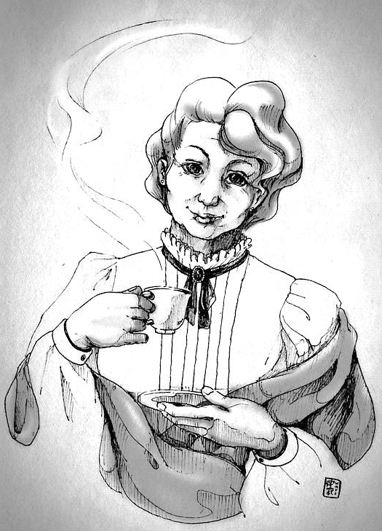
“Please come in,” she said pleasantly. She stepped aside, holding the door wide open, and Billy found himself automatically starting forward into the house. The compulsion or, more accurately, the desire to follow after her into that house was extraordinarily strong.
“I saw the notice in the window,” he said, holding himself back.
“Yes, I know.”
“I was wondering about a room.”
“It's all ready for you, my dear,” she said.
She had a round pink face and very gentle blue eyes.
“I was on my way to The Bell and Dragon,” Billy told her. “But the notice in your window just happened to catch my eye.”
“My dear boy,” she said, “why don't you come in out of the cold?”
“How much do you charge?”
“Five and sixpence a night, including breakfast.”
It was fantastically cheap. It was less than half of what he had been willing to pay.
“If that is too much,” she added, “then perhaps I can reduce it just a tiny bit. Do you desire an egg for breakfast? Eggs are expensive at the moment. It would be sixpence less without the egg.”
“Five and sixpence is fine,” he answered. “I should like very much to stay here.”
“I knew you would. Do come in.”
She seemed terribly nice. She looked exactly like the mother of one’s best school-friend welcoming one into the house to stay for the Christmas holidays. Billy took off his hat, and stepped over the threshold.
“Just hang it there,” she said, “and let me help you with your coat.”
There were no other hats or coats in the hall. There were no umbrellas, no walking-sticks – nothing.
“We have it all to ourselves,” she said, smiling at him over her shoulder as she led the way upstairs.
“You see, it isn’t very often I have the pleasure of taking a visitor into my little nest.”
The old girl is slightly dotty, Billy told himself. But at five and sixpence a night, who gives a damn about that? – “I should've thought you’d be simply swamped with applicants,” he said politely.
“Oh, I am, my dear, I am, of course I am.
But the trouble is that I'm inclined to be just a teeny weeny bit choosy and particular – if you see what I mean.”
“Ah, yes.”
“But I’m always ready. Everything is always ready day and night in this house just on the off-chance that an acceptable young gentleman will come along. And it is such a pleasure, my dear, such a very great pleasure when now and again I open the door and I see someone standing there who is just exactly right.” She was half-way up the stairs, and she paused with one hand on the stair-rail, turning her head and smiling down at him with pale lips. “Like you,” she added, and her blue eyes travelled slowly all the way down the length of Billy's body, to his feet, and then up again.
On the first-floor landing she said to him,
“This floor is mine.”
They climbed up a second flight. “And this one is all yours,” she said. “Here’s your room. I do hope you’ll like it.” She took him into a small but charming front bedroom, switching on the light as she went in.
“The morning sun comes right in the window, Mr Perkins. It is Mr Perkins, isn’t it?”
“No,” he said. “It’s Weaver.”
“Mr Weaver. How nice. I’ve put a water-bottle between the sheets to air them out, Mr Weaver. It’s such a comfort to have a hot water-bottle in a strange bed with clean sheets, don’t you agree? And you may light the gas fire at any time if you feel chilly.”
“Thank you,” Billy said. “Thank you ever so much.” He noticed that the bedspread had been taken off the bed, and that the bedclothes had been neatly turned back on one side, all ready for someone to get in.
“I’m so glad you appeared,” she said, looking earnestly into his face. “I was beginning to get worried.”
“That’s all right,” Billy answered brightly.
“You mustn’t worry about me.” He put his suitcase on the chair and started to open it.
“And what about supper, my dear? Did you manage to get anything to eat before you came here?”
“I’m not a bit hungry, thank you,” he said. “I think I’ll just go to bed as soon as possible because tomorrow I’ve got to get up rather early and report to the office.”
“Very well, then. I’ll leave you now so that you can unpack. But before you go to bed, would you be kind enough to pop into the sitting-room on the ground floor and sign the book? Everyone has to do that because it’s the law of the land, and we don’t want to go breaking any laws at this stage in the proceedings, do we?” She gave him a little wave of the hand and went quickly out of the room and closed the door.
Now, the fact that his landlady appeared to be slightly off her rocker didn’t worry Billy in the least. After all, she was not only harmless – there was no question about that – but she was also quite obviously a kind and generous soul. He guessed that she had probably lost a son in the war, or something like that, and had never got over it.
So a few minutes later, after unpacking his suitcase and washing his hands, he trotted downstairs to the ground floor and entered the living-room. His landlady wasn’t there, but the fire was glowing in the hearth, and the little dachshund was still sleeping in front of it.
The room was wonderfully warm and cosy. I’m a lucky fellow, he thought, rubbing his hands. This is a bit of all right. He found the guest-book lying open on the piano, so he took out his pen and wrote down his name and address. There were only two other entries above his on the page, and, as one always does with guest-books, he started to read them. One was a Christopher Mulholland from Cardiff. The other was Gregory W. Temple from Bristol. That’s funny, he thought suddenly. Christopher Mulholland. It rings a bell. Now where on earth had he heard that rather unusual name before?
Was he a boy at school? No. Was it one of his sister’s numerous young men, perhaps, or a friend of his father’s? No, no, it wasn’t any of those. He glanced down again at the book. Christopher Mulholland, 231 Cathedral Road, Cardiff. Gregory W. Temple, 27 Sycamore Drive, Bristol. As a matter of fact, now he came to think of it, he wasn’t at all sure that the second name didn’t have almost as much of a familiar ring about it as the first.
“Gregory Temple?” he said aloud, searching his memory. “Christopher Mulholland? ...”
“Such charming boys,” a voice behind him answered, and he turned and saw his landlady sailing into the room with a large silver tea-tray in her hands. She was holding it well out in front of her, and rather high up, as though the tray were a pair of reins on a frisky horse.
“They sound somehow familiar,” he said.
“They do? How interesting.”
“I’m almost positive I’ve heard those names before somewhere. Isn’t that queer? Maybe it was in the newspapers. They weren’t famous in any way, were they? I mean famous cricketers or footballers or something like that?”
“Famous,” she said, setting the tea-tray down on the low table in front of the sofa. “Oh no, I don’t think they were famous. But they were extraordinarily handsome, both of them, I can promise you that. They were tall and young and handsome, my dear, just exactly like you.”
Once more, Billy glanced down at the book.
“Look here,” he said, noticing the dates. “This last entry is over two years old.”
“It is?”
“Yes, indeed. And Christopher Mulholland’s is nearly a year before that – more than three years ago.”
“Dear me,” she said, shaking her head and heaving a dainty little sigh. “I would never have thought it. How time does fly away from us all, doesn’t it, Mr Wilkins?”
“It’s Weaver,” Billy said. “W-e-a-v-e-r.”
“Oh, of course it is!” she cried, sitting down on the sofa. “How silly of me. I do apologise. In one ear and out the other, that’s me, Mr Weaver.”
“You know something?” Billy said. “‘Something that’s really quite extraordinary about all this?”
“No, dear, I don’t.”
“Well, you see – both of these names, Mulholland and Temple, I not only seem to remember each one of them separately, so to speak, but somehow or other, in some peculiar way, they both appear to be sort of connected together as well. As though they were both famous for the same sort of thing, if you see what I mean – like ... like Dempsey and Tunney, for example, or Churchill and Roosevelt.”
“How amusing,” she said. “But come over here now, dear, and sit down beside me on the sofa and I’ll give you a nice cup of tea and a ginger biscuit before you go to bed.”
“You really shouldn’t bother,” Billy said. “I didn’t mean you to do anything like that.”
He stood by the piano, watching her as she fussed about with the cups and saucers. He noticed that she had small, white, quickly moving hands, and red finger-nails.
“I’m almost positive it was in the newspapers I saw them,” Billy said. “I’ll think of it in a second. I’m sure I will.” There is nothing more tantalising than a thing like this which lingers just outside the borders of one’s memory. He hated to give up.
“Now wait a minute,” he said. “Wait just a minute. Mulholland ... Christopher Mulholland ... wasn’t that the name of the Eton schoolboy who was on a walking-tour through the West Country, and then all of a sudden ...”
“Milk?” she said. “And sugar?”
“Yes, please. And then all of a sudden ...”
“Eton schoolboy?” she said. “Oh no, my dear, that can’t possibly be right because my Mr Mulholland was certainly not an Eton schoolboy when he came to me. He was a Cambridge undergraduate. Come over here now and sit next to me and warm yourself in front of this lovely fire. Come on. Your tea’s all ready for you.” She patted the empty place beside her on the sofa, and she sat there smiling at Billy and waiting for him to come over. He crossed the room slowly, and sat down on the edge of the sofa. She placed his teacup on the table in front of him.
“There we are,” she said. “How nice and cosy this is, isn’t it?”
Billy started sipping his tea. She did the same. For half a minute or so, neither of them spoke. But Billy knew that she was looking at him. Her body was half-turned towards him, and he could feel her eyes resting on his face, watching him over the rim of her teacup.
Now and again, he caught a whiff of a peculiar smell that seemed to emanate directly from her person. It was not in the least unpleasant, and it reminded him – well, he wasn’t quite sure what it reminded him of.
Pickled walnuts? New leather? Or was it the corridors of a hospital?
“Mr Mulholland was a great one for his tea,” she said at length. “Never in my life have I seen anyone drink as much tea as dear, sweet Mr Mulholland.”
“I suppose he left fairly recently,” Billy said.He was still puzzling his head about the two names.
He was positive now that he had seen them in the newspapers – in the headlines.
“Left?” she said, arching her brows. “But my dear boy, he never left. He’s still here. Mr Temple is also here. They’re on the third floor, both of them together.”
Billy set down his cup slowly on the table, and stared at his landlady. She smiled back at him, and then she put out one of her white hands and patted him comfortingly on the knee. “How old are you, my dear?” she asked.
“Seventeen.”
“Seventeen!” she cried. “Oh, it’s the perfect age! Mr Mulholland was also seventeen. But I think he was a trifle shorter than you are, in fact I’m sure he was, and his teeth weren’t quite so white. You have the most beautiful teeth, Mr Weaver, did you know that?”
“They’re not as good as they look,” Billy said.
“They’ve got simply masses of fillings in them at the back.”
“Mr Temple, of course, was a little older,” she said, ignoring his remark. “He was actually twenty eight. And yet I never would have guessed it if he hadn’t told me, never in my whole life. There wasn’t a blemish on his body.”
“A what?” Billy said.
“His skin was just like a baby’s.” There was a pause. Billy picked up his teacup and took another sip of his tea, then he set it down again gently in its saucer. He waited for her to say something else, but she seemed to have lapsed into another of her silences. He sat there staring straight ahead of him into the far corner of the room, biting his lower lip.
“That parrot,” he said at last. “You know something? It had me completely fooled when I first saw it through the window from the street. I could have sworn it was alive.”
“Alas, no longer.”
“It’s most terribly clever the way it’s been done,” he said. “It doesn’t look in the least bit dead. Who did it?”
“I did.”
“You did?”
“Of course,” she said. “And have you met my little Basil as well?” She nodded towards the dachshund curled up so comfortably in front of the fire. Billy looked at it. And suddenly, he realised that this animal had all the time been just as silent and motionless as the parrot. He put out a hand and touched it gently on the top of its back. The back was hard and cold, and when he pushed the hair to one side with his fingers, he could see the skin underneath, greyish-black and dry and perfectly preserved.
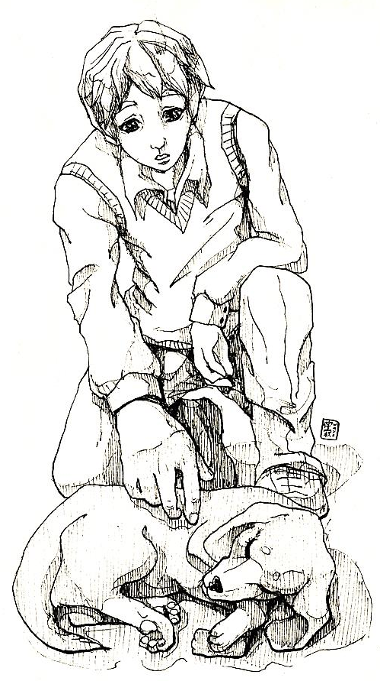
“Good gracious me,” he said. “How absolutely fascinating.” He turned away from the dog and stared with deep admiration at the little woman beside him on the sofa. “It must be most awfully difficult to do a thing like that.”
“Not in the least,” she said. “I stuff all my little pets myself when they pass away. Will you have another cup of tea?”
“No, thank you,” Billy said. The tea tasted faintly of bitter almonds, and he didn’t much care for it.
“You did sign the book, didn’t you?”
“Oh, yes.”
“That’s good. Because later on, if I happen to forget what you were called, then I can always come down here and look it up. I still do that almost every day with Mr Mulholland and Mr . . .Mr...”
“Temple,” Billy said. “Gregory Temple. Excuse my asking, but haven’t there been any other guests here except them in the last two or three years?”
Holding her teacup high in one hand, inclining her head slightly to the left, she looked up at him out of the corners of her eyes and gave him another gentle little smile.
“No, my dear,” she said. ‘Only you.'

The Landlady: Questions
Name: _________________________

Answer each question below on a SEPARATE SHEET OF PAPER. Your answers need to be in FULL SENTENCES. Attach these questions to your answer sheet.

- Why is Billy drawn to the window of the boardinghouse? Why does Billy decide to stay at the boardinghouse?

- What makes Billy assume that the landlady is harmless? Give 3 examples from the text.

- What does Billy discover about the landlady’s pets? Why do you believe Billy is more curious about this than scared of them?

- What might you infer about what is going to happen at the end of the story?
(Hint: cyanide has the taste of bitter almonds)

- Does the story agree or disagree with this statement: “Don’t judge a book by its cover.” Be able to explain WHY you think this, with references to the text.

The Landlady: Questions

Answer each question below on a separate sheet of paper. Your answers need to be in full sentences. Attach these questions to your answer sheet.

- Define the following:
  - Façades
  - Rapacious
  - Dotty
  - Emanate

- Who is the protagonist?

- What does the bed and breakfast look like?

- Give 3 examples from the text of what the woman looks like.

- How does Billy react to the names in the guest book?

- What does Billy discover about the landlady’s pets?

- What might happen at the end of the story? (Hint: Arsenic has the taste of bitter almonds)

Define the following:
  - Dithering
  - Façades
  - Rapacious
  - Dotty
  - Emanate

