Ozymandias
Percy Bysshe Shelley

¹I met a traveller from an antique land,
Who said—“Two vast and trunkless legs of stone
Stand in the desert. . . . Near them, on the sand,
Half sunk a shattered visage lies, whose frown,
⁵And wrinkled lip, and sneer of cold command,
Tell that its sculptor well those passions read
Which yet survive, stamped on these lifeless things,
The hand that mocked them, and the heart that fed;
And on the pedestal, these words appear:
¹⁰My name is Ozymandias, King of Kings;
Look on my Works, ye Mighty, and despair!
Nothing beside remains. Round the decay
Of that colossal Wreck, boundless and bare
₁₄The lone and level sands stretch far away.”

Ozymandias Questions
Answer the following (can be in point form)

- What type of poem is “Ozymandias”? ________________________________________________

- Who is telling the story of Ozymandias? ________________________________________________

- What does the statues abandonment symbolize?
- "No man is an island"
- The eventual downfall of power
- The loneliness everyone feels
- Absence of government in a society

- Line 5 contains an example of what literary device (‘and sneer of cold command’)?
________________________________________________

- Select a line that does NOT make use of alliteration in the poem.
- The lone and level sands stretch far away
- Nothing beside remains. Round the decay
- Stand in the desert… Near them, on the sand
- And wrinkled lip, and sneer of cold command

- What are "trunkless" legs? (line 2) ____________________________________________________

- The 'shatter'd visage,' as described in Percy Shelley's “Ozymandias”, refers to what?
___________________________________________________________

- In the statement “Look on my works, ye Mighty, and despair!” (line 11) Ozymandias is speaking to...
- the sculptor of the statue
- Percy Bysshe Shelley
- gods and/or other powerful figures
- the traveler

- What is the irony of "Ozymandias"?
- Ozymandias thought he would be eternally powerful with his statue, yet the only lasting pieces of his legacy are in ruins.
- The traveller turns out to be the "king of kings", something nobody saw coming.
- The sculptor made a mistake when creating the statue, and that is why it has not lasted through time.
- The expression of the "shattered visage" is actually comical since it is a frown upside down.

- What is the central theme of the poem “Ozymandias”?
  - Material things will eventually be destroyed
  - Fate declares the wicked are punished for their crimes
  - All gods have mortal traits
  - No man's pride will survive and ultimately it lead to his fall and decline in power

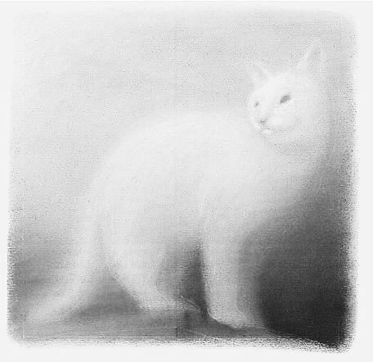
Fog – Carl Sandburg
The fog comes
On little cat feet.
It sits looking over harbor and city
On silent haunches
And then moves on.

Fire and Ice – Robert Frost
Some say the world will end in fire,
Some say in ice.
From what I’ve tasted of desire
I hold with those who favor fire.
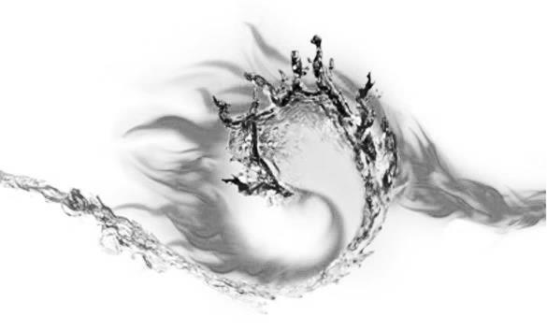
But if it had to perish twice,
I think I know enough of hate
To say that for destruction ice
Is also great
And would suffice.

Fog – Questions

- Based on the poem, and what you know about these two items, compare qualities of a cat, to those of fog.

Cat | Fog

- Why does this metaphor work? USE FULL SENTENCES FOR THIS QUESTION.

_______________________________________________________________________________________________________________________________________________________________________________________________________________________________________________________________
__________________________________________________________________________________________________________________________________________________________________________
- Think of another example between an element of nature and an animal. Write a simple poem (similar to ‘Fog’) that compares the two.

Fire and Ice – Questions
- Based on the poem, and these four items, write down how they compare to each other. (Compare desire and fire to each other, and hate and ice to each other)

Desire | Fire
Hate | Ice

- Why do these two metaphors work? USE FULL SENTENCES FOR THIS QUESTION.

_______________________________________________________________________________________________________________________________________________________________________________________________________________________________________________________________
__________________________________________________________________________________________________________________________________________________________________________
_____________________________________________________________________________________
__________________________________________________________________________________________________________________________________________________________________________
Identity - Julio Noboa Polanco

¹Let them be as flowers,
always watered, fed, guarded, admired,
but harnessed to a pot of dirt.

⁴I’d rather be a tall, ugly weed,
clinging on cliffs, like an eagle
wind-wavering above high, jagged rocks.

⁷To have broken through the surface of stone,
to live, to feel exposed to the madness
of the vast, eternal sky.
To be swayed by the breezes of the ancient sea,
carrying my soul, my seed, beyond the mountains of time
or into the abyss of the bizarre.

¹³I’d rather be unseen, and if
then shunned by everyone
than to be a pleasant-smelling flower,
growing in clusters in the fertile valley,
where they’re praised, handled, and plucked
by greedy, human hands.

¹⁹I’d rather smell of musty, green stench
than of sweet, fragrant lilac.
If I could stand alone, strong and free,
I’d rather be a tall, ugly weed.

Identity - Questions

- Who might be the speaker of the poem? Explain your reasoning.
_______________________________________________________________________________________________________________________________________________________________________________________________________________________________________________________________
- What is the tone of the poem? Give a specific example from the poem to support your answer.
_______________________________________________________________________________________________________________________________________________________________________________________________________________________________________________________________
- Are similes, metaphor, and/or personification present in the poem? If so, give specific examples from the poem of each device.
Similes: ______________________________________________________________________________
Metaphor: ____________________________________________________________________________
Personification: ________________________________________________________________________

- Based on the poem, compare the difference between a flower and an ugly weed. Use examples from the poem. You must have at least 3 examples of each.

Flower | Ugly Weed

The Shark
Edwin John Pratt

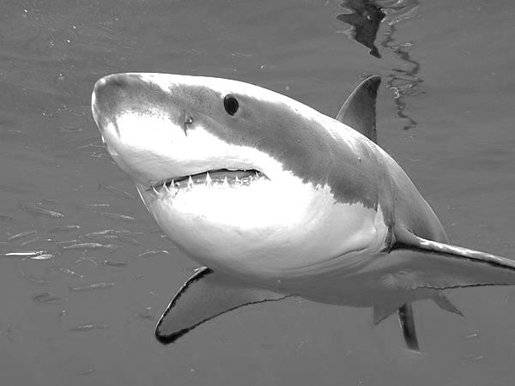
He seemed to know the harbour,
So leisurely he swam;
His fin,
Like a piece of sheet-iron,
Three-cornered,
And with knife-edge,
Stirred not a bubble
As it moved
With its base-line on the water.
His body was tubular
And tapered
And smoke-blue,
And as he passed the wharf
He turned,
And snapped at a flat-fish
That was dead and floating.
And I saw the flash of a white throat,
And a double row of white teeth,
And eyes of metallic grey,
Hard and narrow and slit.
Then out of the harbour,
With that three-cornered fin
Shearing without a bubble the water
Lithely,
Leisurely,
He swam—
That strange fish,
Tubular, tapered, smoke-blue,
Part vulture, part wolf,
Part neither—for his blood was cold.
The Shark - Questions

- What figurative language is used in the first stanza? Give an example of it.
_____________________________________________________________________________________
_____________________________________________________________________________________
_____________________________________________________________________________________
- Identify words in the second stanza that suggest the shark is a dangerous creature. You should have at least 3-4 descriptive words.
_____________________________________________________________________________________
_____________________________________________________________________________________
_____________________________________________________________________________________
_____________________________________________________________________________________
- What are the meanings of “lithe” and “leisurely” from the third stanza? Use a dictionary to find these.
Lithe: ________________________________________________________________________________
Leisurely: _____________________________________________________________________________

- In the final stanza, the shark is described as “part vulture, part wolf”. Explain why the comparisons are appropriate.
_____________________________________________________________________________________
_____________________________________________________________________________________
_____________________________________________________________________________________
- What impression is given of the shark, given that it is not actively preying on anything at the time?
_____________________________________________________________________________________
_____________________________________________________________________________________
_____________________________________________________________________________________
_____________________________________________________________________________________

Water Picture – May Swenson

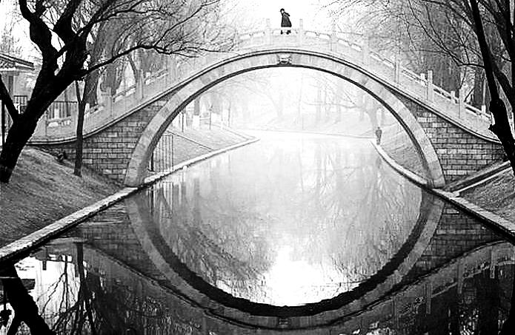
In the pond in the park
all things are doubled:
Long buildings hang and
wriggle gently. Chimneys
are bent legs bouncing
on clouds below. A flag
wags like a fishhook
down there in the sky.
The arched stone bridge
is an eye, with underlid
in the water. In its lens
dip crinkled heads with hats
that don't fall off. Dogs go by,
barking on their backs.
A baby, taken to feed the
ducks, dangles upside-down,
a pink balloon for a buoy.
Treetops deploy a haze of
cherry bloom for roots,
where birds coast belly-up
in the glass bowl of a hill;
from its bottom a bunch
of peanut-munching children
is suspended by their
sneakers, waveringly.
A swan, with twin necks
forming the figure 3,
steers between two dimpled
towers doubled. Fondly
hissing, she kisses herself,
and all the scene is troubled:
water-windows splinter,
tree-limbs tangle, the bridge
folds like a fan.
Water Picture - Questions

1. Give an example of a metaphor and personification in the poem.
_______________________________________________________________________________________________________________________________________________________________________________________________________________________________________________________________

2. In the poem, identify three separate examples of alliteration.
_______________________________________________________________________________________________________________________________________________________________________________________________________________________________________________________________

3. In the final stanza, find an example of assonance.
_______________________________________________________________________________________________________________________________________________________________________________________________________________________________________________________________

4. How is the world altered by the different perspective Swensen sees? Give two examples.
__________________________________________________________________________________________________________________________________________________________________________

5. What upsets the reflections in the end?
_______________________________________________________________________________________________________________________________________________________________________________________________________________________________________________________________

