Pick one of the comic strips to practice before you start your pandemic script.
There is an example from another play to see how a scene is “scripted” out.

Model Comic Strip

Title: Blackmail by Snoopy

Characters:

Linus

Setting: Linus’

watches.

Snoopy

house. Linus is writing a letter while Snoopy

LINUS: (writing) I would like to recommend Snoopy for Neighborhood Dog of the Year. He is truly a dog among dogs.

(turning to Snoopy) How’s that?

SNOOPY: Great! (Snoopy gives Linus his blanket.)

LINUS: What a way to get your blanket back!

SNOOPY: What a way to get a letter of recommendation!
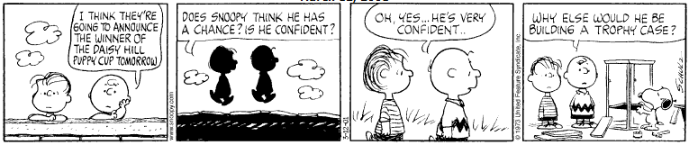
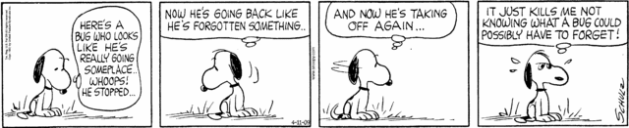
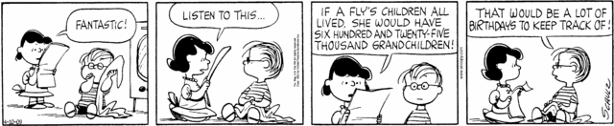
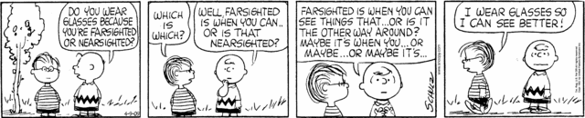
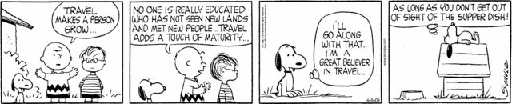
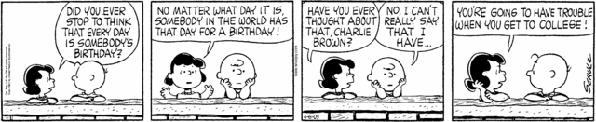
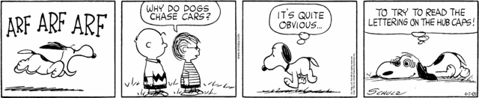
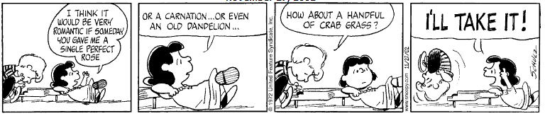

Basic Script Outline

Title: _________________________________

Characters:

Setting: ____________________________________
______________________________________________ ______________________________________________

FRANKENSTEIN
By Mary Wollstonecraft Shelley, adapted for radio by Antony Ellis (06/07/1955)

DR. VICTOR FRANKENSTEIN

HENRY (Victor’s friend)
Characters
FRANKENSTEIN’S MONSTER

ELIZABETH (Victor’s cousin & girlfriend)

Setting: Henry’s house, on the back porch, late in the evening.
Prior to this scene, Dr. Frankenstein created a monster. When his monster starts destroying things and killing people, Dr. Frankenstein runs away to England, hoping to leave the evil monster behind him.

ELIZABETH: (screaming) Victor! Victor!

VICTOR: We’re out here, Beth.

ELIZABETH: Oh I’ve just had a horrible experience. Darling, I’m so glad to see you!

VICTOR: You’re pale, Beth. Sit down right here next to me.

HENRY: Oh, what happened, Beth?

ELIZABETH: I was . . . I was walking in the woods not far from here when I looked up and saw . . . and saw a man . . . sort of a man standing over me.

HENRY: Well men aren’t so bad, that is if you happen to know the right ones, and you do.

ELIZABETH: I’m not joshing, Henry. He was not exactly a man. He was twice the height of anyone I’d ever seen. And his skin looked like dried parchment. It’s incredible, but I think I’ve seen a monster.

HENRY: Monster?

ELIZABETH: Yes, I . . . I ran away. He didn’t follow me; just, just stared after me. Watching me. You do believe me, don’t you?

HENRY: A monster stared after you?

ELIZABETH: Oh, look, look! Henry, Victor, through the trees right out there! Look! There he is again!

(wind blowing)

VICTOR: (narrating) Yes, the monster stood there silhouetted against the trees. The monster which I had created, standing like an evil blot of flesh and blood, moved in the darkening

twilight, and then suddenly, phantom-like, it disappeared. Beth and Henry both watched me as I started from the piazza after the disappearing creature in the back woods.

As I drew near to the heavily-wooded section, giant footprints in the soft mud about me showed the path ahead. The sun was sinking in the west, and the last orange pinpoints of light needled my flesh until every sense within me was tingling with the expectation of seeing my living horror.

Then I realized I was unarmed. Every crooked tree, each twisted branch which obstructed my path appeared to be his form.

(branch snaps)

I heard the crackling of a branch and the moving of a form on the velvet moss.

FRANKENSTEIN’S MONSTER: I thought you’d come, Creator.

VICTOR: You!

FRANKENSTEIN’S MONSTER: Are you frightened, Creator?

VICTOR: You dare talk to me!

FRANKENSTEIN’S MONSTER: Please don’t turn away from me. Please.

VICTOR: Let me go!

FRANKENSTEIN’S MONSTER: Please. I mean no harm to you. Listen to me, Victor Frankenstein. You must listen to me. You created me. You owe me that much.

VICTOR: I owe you nothing, murderer!

FRANKENSTEIN’S MONSTER: Why am I a murderer? Because you created a form so horrible, a face so distorted that no man can look upon me and call me friend. I’m an outcast. You can save me.

